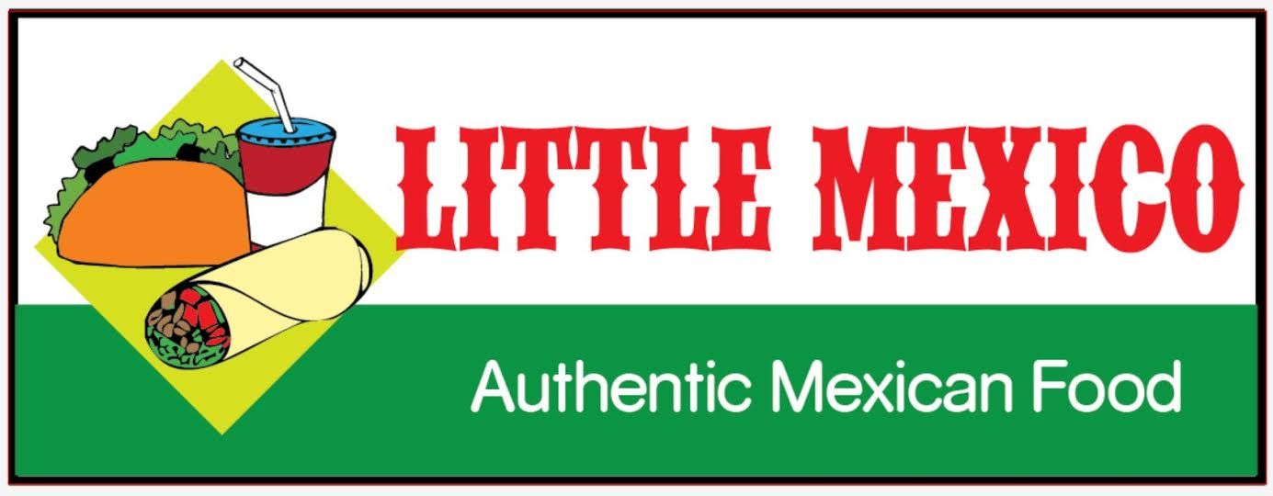
A cultural guide for our teammates
LITTLE MEXICO
Guidelines & Policies
for the culture of Little Mexico

Contents –
- Introduction – page 2
- Universal Guide & Expectations for LM teammates – page 3
- Guidelines (cont.) – page 4
- Managing LM – page 5
- Window Dispatcher & Order Taker assignment & tasks – page 6
- Meal Maker assignment & tasks – page 7
- Tortillas prepper assignment & tasks – page 8
- Food prepper assignment & tasks – page 9
- Prepping & cooking breakfast items – page 10

Welcome to the team of Little Mexico,
Our primary focus is to ensure we are a team that respects, values & cares for each other. Money isn’t the cause; it is the results of proper teamwork & care for each other & customers! To serve with care to each other & the community.
We are human so mistakes will be made and I assure you that working with our team will help you grow & learn from those lessons (mistakes), after all; one way to learn is by making mistakes & correcting them. These guides will get better over time, so don’t feel like everything has to be perfect the first time. Be the pioneer!
We do expect respect, compassionate support & loving kindness towards each other. We essentially are a group of individuals working together towards the same goal, to provide high quality customer service, food & overall value to human beings.

Questions about anything in this guidebook, please feel free to ask.
_______________________________- owners contact info.
Or contact Ricardo Picena 469-474-9090

Universal Guides & expectations of our Teammates

One of our focus is to help us steer each other to create a happy & progressive environment in our workspace.
Join the team & grow together while providing quality food to the community.

- Optimistic attitude – we believe that creating the habit of happiness relies on the conscious effort of seeing the positive in every situations & looking for a solution where everyone wins. We also believe that having a good attitude is a great sign of respect towards yourself, towards the rest of the team & the business itself.

- Accommodate to our workspace, adapt quickly – learning to learn quickly is a good skill & habit. Focusing primarily on one task at a time & practicing it over and over will help us adapt faster & progress quicker in our workspace.

- Fast track work when the times calls for it, able to work fast & neatly with other teammates – Loved ones, again; the habit of learning to adapt quickly will allow us to progress faster when customers heap on us. Keep your optimistic attitude!

- Be Respectful & open to respectful constructive critique if needed – As a respectful team, no one has power over anyone, everyone is their own individual & we are part of the team to bring value to each other, the business & the customers. Respect will take us far in life.
- Hygiene – Please always come to work clean, wear gloves, hair nets or caps, wash hands often & when required. Have your work gear & clothes, clean & ready for the task.

Guidelines

“Creating a Culture of Love & Prosperity through our Work Ethic!”
Teammate guides & workspace systems that helps allow anyone to run the business.
“Systems run the business & people run the systems.”
Work Systems help maintain consistency, they help the people running the system to manage the business with ease by creating a list or book of technics to running the business orderly & consistent.
To serve the community & beyond!!!

Managing Little Mexico

- Please learn every position assignments of your teammates, to better help every person assigned to their position, task or duty.

- Make owner aware of major issues, complaints, or important messages, unless stated otherwise or handled by others.

- Please check inventory daily as soon as you arrive to your position’s tasks.

- Restock items if needed. (see Item list page)

- Use the items in stock the longest first & the new inventory stock behind or labels as new inventory. Please be sure to label which is new & which is first to be used.

- Maintain every item organized, the location where its stored; clean & labeled.

- Kindly remind your team if they need help, kindly show them how to do the task.

Be a leader that creates other leaders. Be kind & loving when teaching a team member. Helping each other is a part of building good relationships with your team members & helps you build better character.

Window dispatcher & order taker
Always be positive & courteous to teammates & customers.
- Welcome & greet the customers with love & kindness, we are here primarily to serve the team & community; THAT IS OUR FIRST TASK <3

- Write orders down/ take order , give copy of the order to the “Meal Prepper” (person making the food) if needed

-Verify the order with customer before & after giving them their order.
-Verify the order with the person assigned the “Meal Prepper” before giving the order to the customer to ensure the order is right.
-If any orders are wrong or accident happens with an order, fix the order by making their food again. LET THEM KEEP THE WRONG ORDER (health code) please apologize for the incident & kindly give them their correct order. ASK FOR A REVIEW ONLINE WITH YOUR NAME
- Stock paper bags with napkin & advertising fliers if available. Also if available, we print our own logos out & stick them in the bags. If those are available, please be sure to stick those on the bags accordingly.
- Stock drinks up & organize them accordingly.
- Stock item utensils around your area like:
cups, bags, forks & spoons, picnic utensils packages, to-go plastic bags, napkins, salt & pepper packages, foil packs for wrapping burritos, plates for to-go orders. (see “item list” pg & follow thoroughly)

- Keep all items organized & their areas clean.
Team working builds great relationships among other positive traits.
Meal Maker

- Please learn where food items are organized & stocked, this will help the orders get to the customer quicker & hotter.

- Please check your work area & please be sure to have all your items stocked & refilled when needed to be. They should be labeled & organized accordingly. Although the person assigned “food prepping” will also check on your work area to reinsure everything is restoked; being prepared & prompt in your work area benefits the whole team.

- Stock all items required for breakfast & lunch. (see “opening day prep.” Pg. for details)

- Stock the food warmer with the items required for the day. (see “opening day prep” pg. for items detail)

- Stock all veggies & their trays with fresh produce daily. (see “opening day prep” pg. for item detail)

- The “window dispatcher” will give you orders as they come in from the customers, verify orders with the “window dispatcher” to ensure the orders are correct.

- Please keep area clean.

- Learn “food prepper” guides, at slow times & days; helping the person “food prepping” will help each other build a strong relationship as teammates & will complete the daily tasks faster.
“Respect yourself & others will learn how to themselves!”

Tortilla prep.

Flour tortillas – prepare the dough as indicated on the bag or as taught. Flour tortillas must be ready before opening, along with corn tortillas. It is ok to have a small batch from the day before to start with. If completely empty, make a small batch of each before opening.
Once finished making flour tortillas, please be sure to wrap them lightly in their indicated cloth; keeps them warmer longer. Place them in their container to maintain warmer.
Corn tortillas – prepare dough as indicated on the bag or as taught. Once finished making corn tortillas, allow for them to cool down & please be sure to wrap them in their cloth & put them in their container once they have cooled.

Some people are fast to adapt to this task & finish faster than others. In these cases, we encourage to help your fellow team members achieve their tasks. Builds stronger bonds between each other. The person assigned “food prepping” has a longer list of tasks to accomplish throughout the day. Any help provided to them will be kindly appreciated.

Food prepper
- Please always be clean, wash hands often & as required. Wear assigned clothing & gear for work position. Wear gloves, apron, hairnet, or cap.

- Stock all food items required for breakfast & lunch. (see “opening day prep.” Pg. for details)

- Stock the food warmer with the items required for the day. (see “opening day prep” pg. for items detail)

- Stock all veggies & their trays with fresh produce daily. (see “opening day prep” pg. for item detail)

- Prepping of the following meats will be require. That includes trimming fat & cutting the meat to their size indicated at the location. The manager or person in charge will inform you on how to cut the meats. Chicken – Beef Fajita – barbacoa etc. etc.

- Learn the proper condiment measurements for each food needed to be prepared. (see” food prep & condiment measurement” pg. for details)

- When cooking the food, please be sure to check on the food being cooked; often & stir if needed.

- Please taste the food when its fully cooked, be sure it taste as it should.

- Keep the food to their proper temperature.
We always encourage to help each other when possible. Some tasks take longer for people to do & others are faster at some tasks. Whichever your case, be kind & helpful to your fellow team member’s.

Opening Day prep
This section is dedicated to give a “check list” of things that should be prepared & ready before opening Little Mexico for business. Be sure to be very well informed on your role & task in the team.

Breakfast Items: flour & corn tortillas –
Pan fried Eggs – mashed Buttered potatoes – mozzarella cheese.
Bacon bits – Little Mexico’s Country Sausage - Little Mexico’s Mexican Chorizo – Grilled Ham– Beef Fajita – Little Mexico’s Barbacoa (shredded beef) – Grilled Chicken – Ground Beef
Pico de Gallo – onion – cilantro – limes – sour cream – refried beans – avocado
Little Mexico’s Red & green salsas
The following list of items must be prepared & ready by the time Little Mexico is ready for lunch. Some items might already be ready as some breakfast items are the same.
Lunch Items: Flour & corn tortillas – corn gorditas
Beef fajita – Grilled chicken – Little Mexico’s barbacoa (shredded beef) –
Pico de Gallo – cilantro – onion – lettuce – limes – sour cream – avocado – refried beans – rice –
mozzarella cheese/cheddar cheese – red & green salsa
These items must be ready by the time Little Mexico is ready to open for business.

Recap on task for breakfast time
manager or person in charge will open with the rest of the team members. The person responsible for checking inventory will double check inventory that morning to be sure its all in order, available & matches the same list of items as the night before inventory. (the person responsible for the afternoon inventory will leave a list of items left, needed & stocked for the morning shift to follow from) the person responsible for the “window dispatcher” tasks will also be restocking inventory from the storage buildings, if possible, help the person assigned to “food prep” or “meal maker” achieve completion on their tasks. The person responsible for “tortillas prep” will focus on that task, some people are fast learners & will accomplish this task faster. The people responsible for “food prepping” & “meal maker” will follow their task & get ready to open for breakfast.
Recap on task for lunch time
Lunch items should be ready by the time assigned at your Little Mexico location. Everyone should be following their assigned tasks, please refer to this manual for more info on task required to do by each job position.
If you like what you read & are ready to be part of the team, please print, sign & date. We will make a copy to the agreement & return the guide.
Print: ___________________________
Sign: ____________________________
Date: ____________________________

Welcome to the team, we hope you enjoy our journey together as we grow & scale the business. Along with finding deeper versions of ourselves & serve our loving community!
Thank you!
-Ricardo Picena & the Little Mexico Team
Contact information
in case of emergencies:

Date of birth:

cell:

email:

address:

alternative phone number:

